

**“CHATIFY WEBSITE FOR MOBILE DEVICES”**

**Group 4**

Names : Christian Frans Mukuan / 1920010040

Deyaninta Ekabriela Permata / 1920010050

Class : 4SC3

Faculty: : Mr Tirta Akdi Toma Mesoya Hulu, S.Kom

CEP CCIT

FAKULTAS TEKNIK UNIVERSITAS INDONESIA

2021

**Developed by**

1. Christian Frans Mukuan / 1920010040
2. Deyaninta Ekabriela Permata / 1920010050



**PROJECT ON**

*CHATIFY WEBSITE FOR MOBILE DEVICE*

**CHATIFY WEBSITE FOR MOBILE DEVICE**

Batch Code : 4 Sc 3

Start Date : 20 April 2020   
End Date : 9 May 2021

Name of Faculty : Mr. Tirta Akdi Toma Mesoya Hulu, S.Kom

Names of Developer :

1. Christian Frans Mukuan / 1920010040
2. Deyaninta Ekabriela Permata / 1920010050

Date of Submission: 10 May 2021

**CERTIFICATE**

This is to certify that this report titled “Chatify Website For Mobile Device” embodies the original work done by Christian Frans Mukuan, and Deyaninta Ekabriela Permata. Project in partial fulfillment of their course requirement at NIIT.

Coordinator:

Mr. Tirta Akdi Toma Mesoya Hulu, S.Kom



**ACKNOWLEDGEMENT**

Authors would like to praise to Allah, Most Merciful bless and so authors can finish this Project 1 entitled **“Chatify Website For Mobile Device”**. Author would like to thanks to Mr.Tirta Akdi Toma Mesoya Hulu, S.Kom as Lecturer who has given useful suggestion which are help author in writing this paper.

The writer realized that this paper far from perfection, then the writer will be very unfettered the chest and was encouraged, if colleagues and the guide's agreeing lecturer gave the suggestion & criticism for this paper perfection.

**SYSTEM ANALYSIS**

**System Summary**:

**Background**:

Social media refers to websites and applications that are designed to allow people to share content quickly, efficiently, and in real-time. While many people access social media through smartphone apps, this communication tool started with computers, and social media can refer to any internet communication tool that allows users to broadly share content and engage with the public.

**Overview**:

Therefore, the author of this project makes a project about the website of social media, named Chatify. Chatify reshapes communication around the globe, allowing you to enjoy not only messaging but also free voice and video calls wherever you find yourself. So, on this website, the user can register their account and buy some stickers to make the communication more fun.

**Script/Programming Language:**

HTML5, CSS3, JavaScript, JQuery, Framework CSS Bootstrap, Framework JS Angular

**USER INTERFACE**

**(HOMEPAGE)**

Desktop Personal Computer:

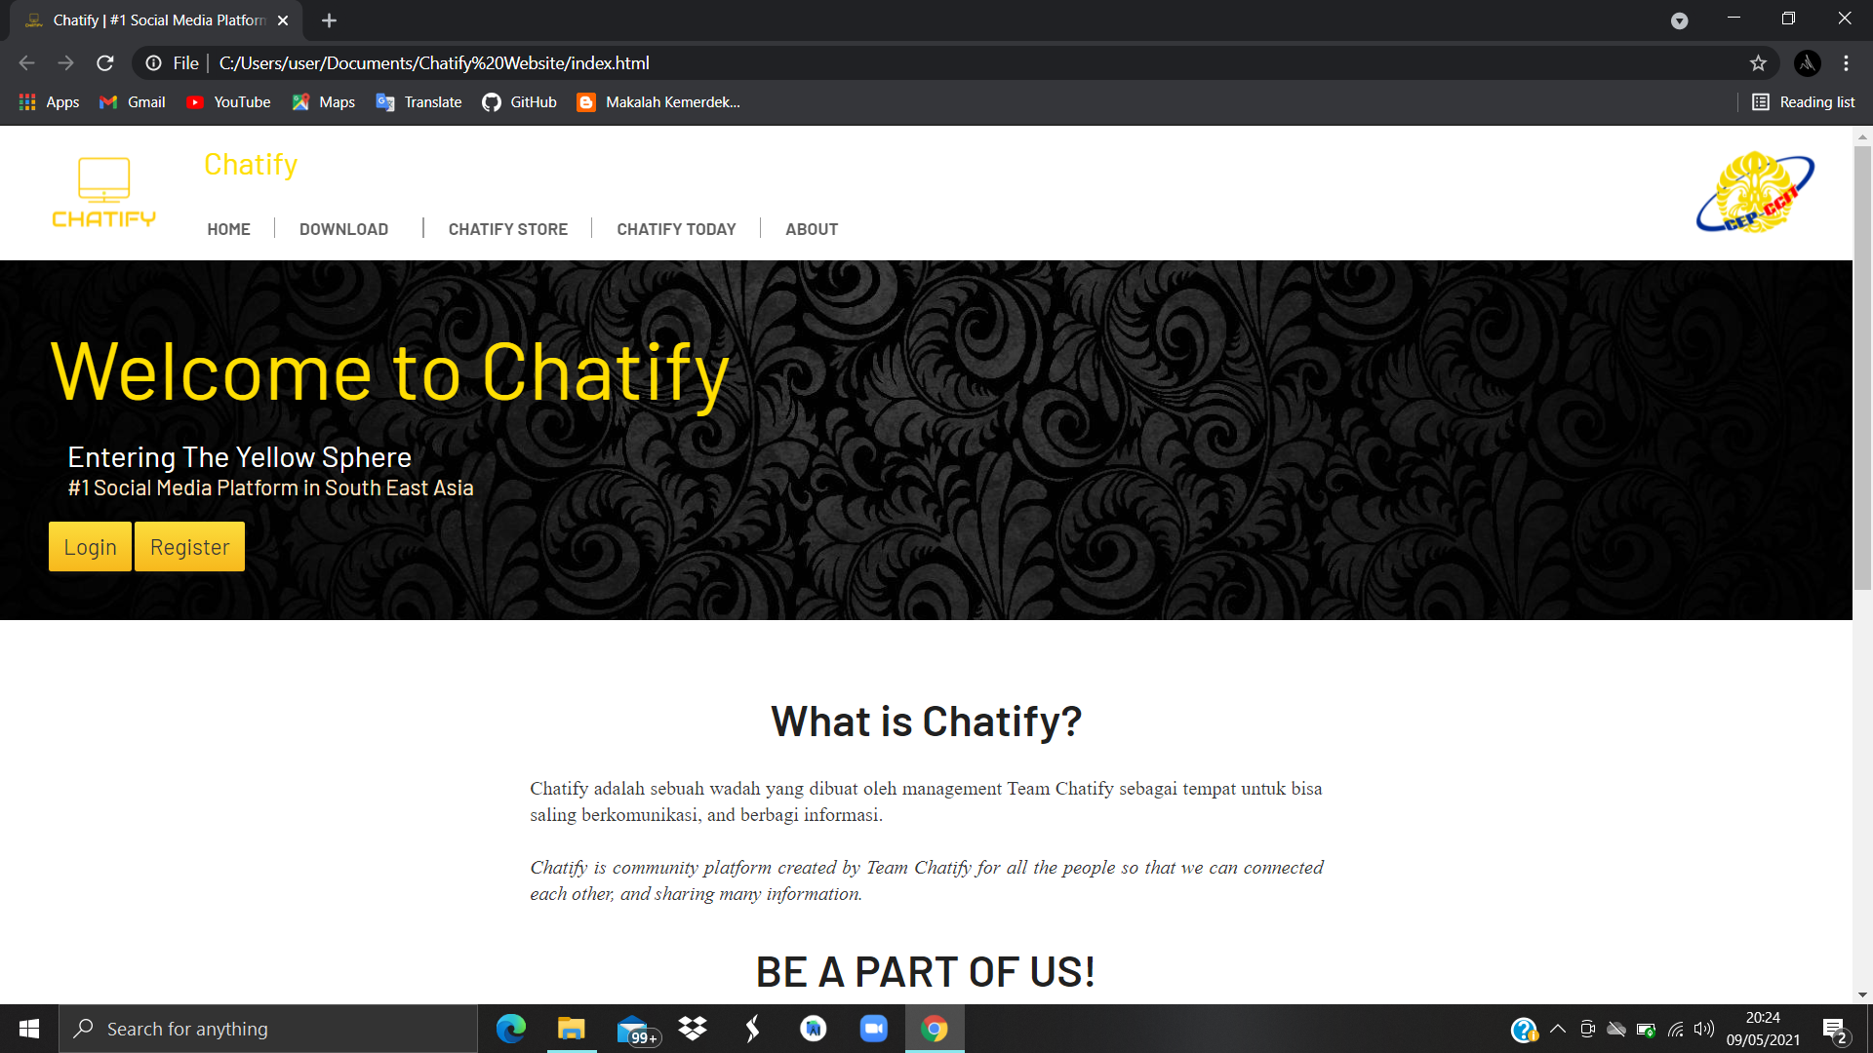

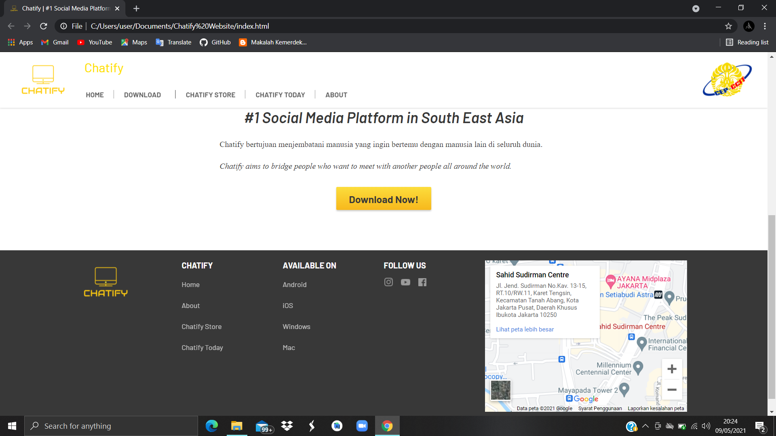

**USER INTERFACE IN MOBILE DEVICES**

**(HOMEPAGE)**

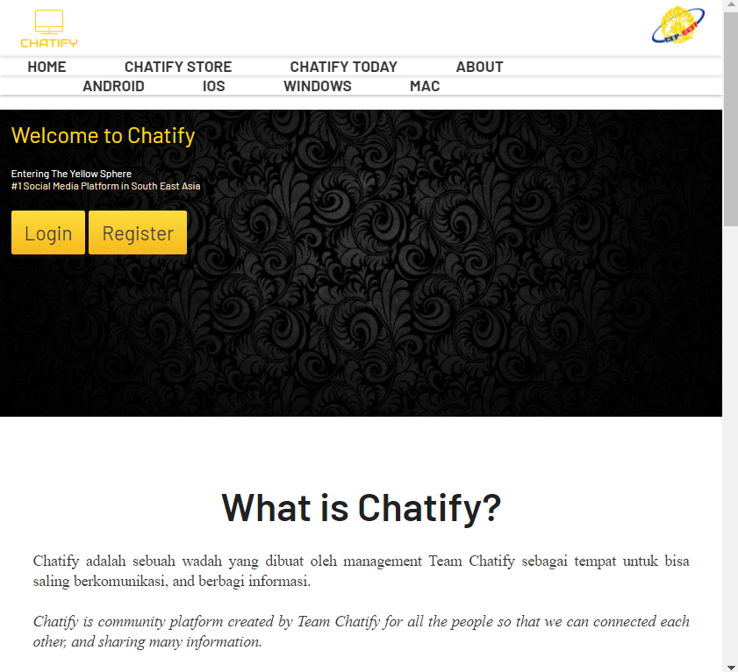

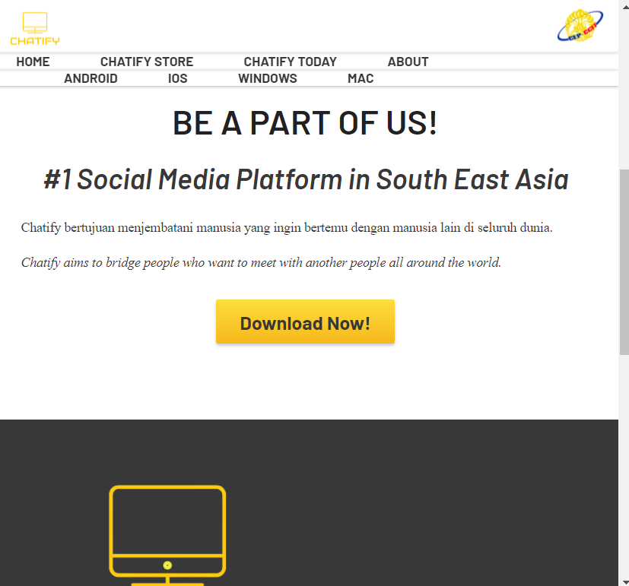

**USER INTERFACE IN MOBILE DEVICES**

**(CHATIFY TODAY/NEWS)**

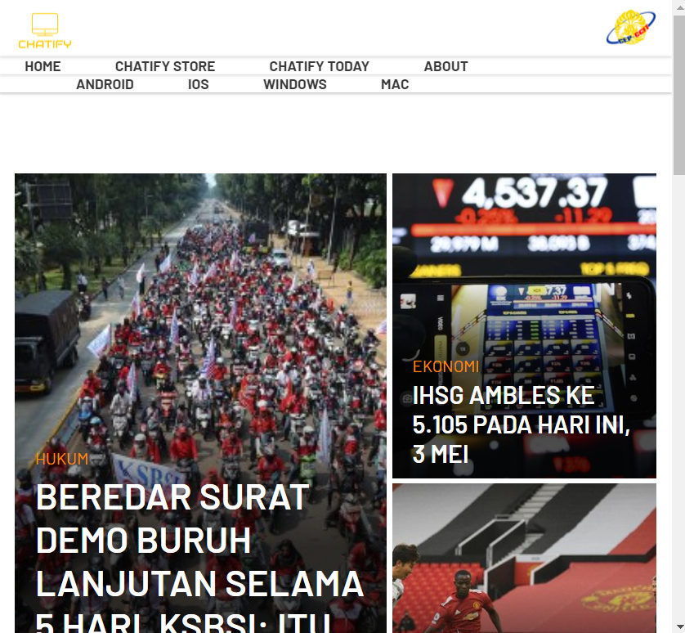

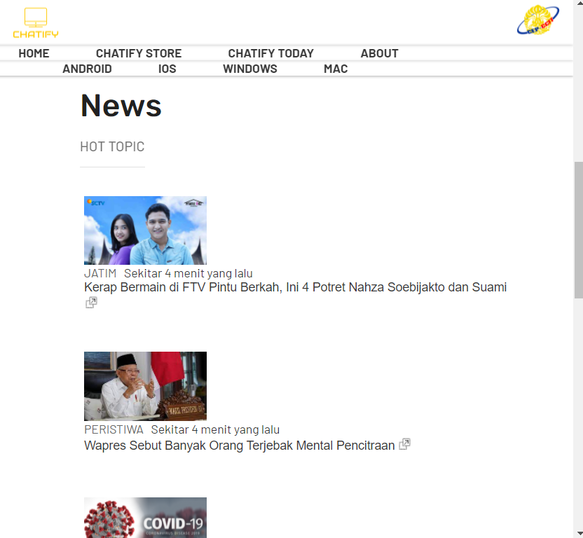

**USER INTERFACE IN MOBILE DEVICES**

**(CHATIFY STORE)**

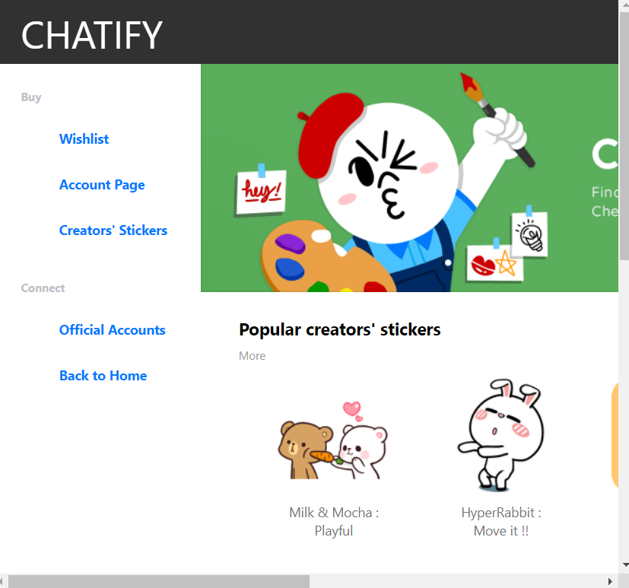

**USER INTERFACE IN MOBILE DEVICES**

**(ABOUT PAGE)**

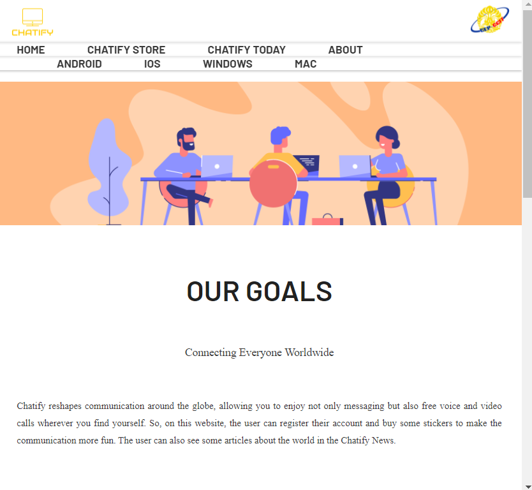

**USER INTERFACE IN MOBILE DEVICES**

**(DOWNLOAD PAGE)**

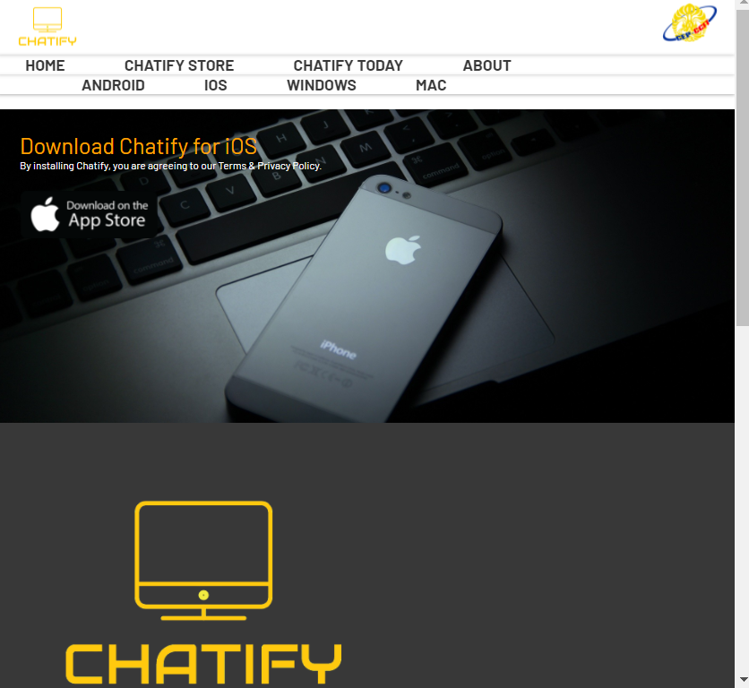

**USER INTERFACE IN MOBILE DEVICES**

**(FOOTER PAGE)**

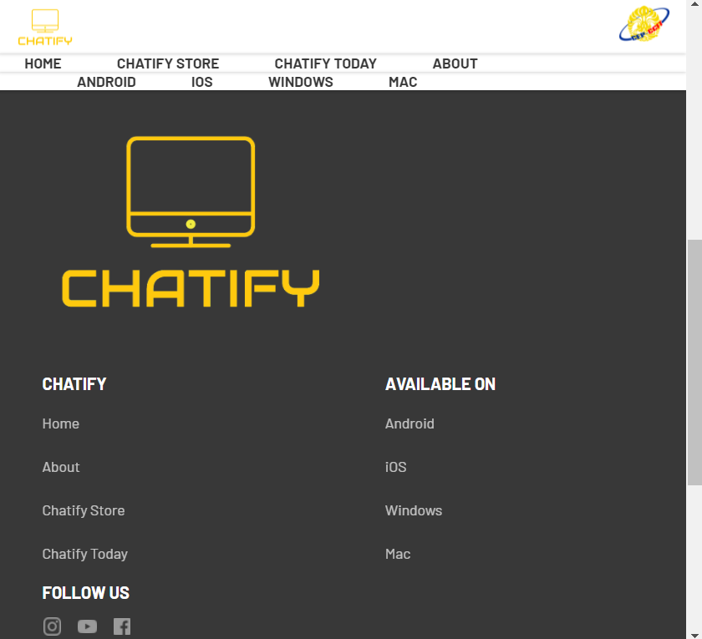

**USER INTERFACE IN MOBILE DEVICES**

**(MAPS)**

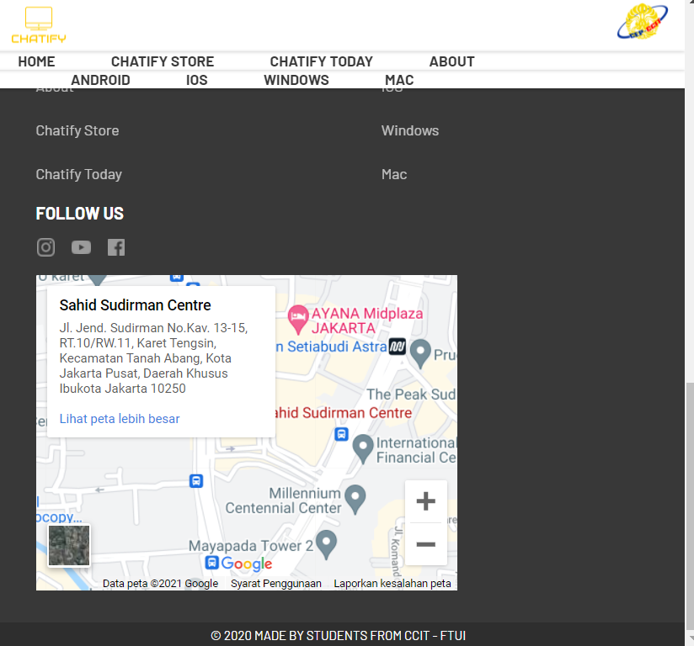

‘

**USER INTERFACE IN MOBILE DEVICES**

**(CONTACT US)**

USE ANGULAR JS

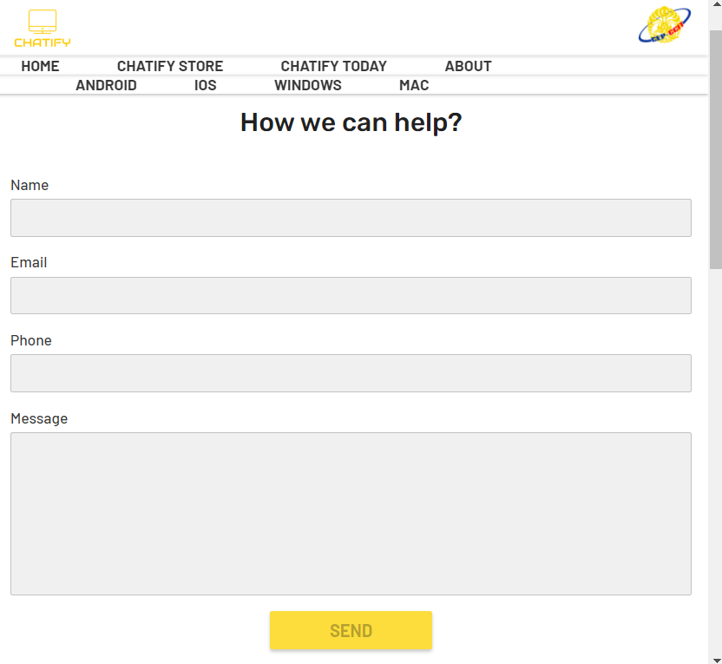

‘

**PROJECT FILE DETAILS**

**Hardware** :

PC compatible with an Intel Core – i5 processor, 4 GB RAM and 128 GB of SSD

**Operating System** :

Microsoft Windows 10

**Software** :

VSCODE

|  |  |  |
| --- | --- | --- |
| **PROJECT FILE DETAILS** | | |
| **S.No** | **File Name** | **Remarks** |
| 1. | ProjekChatify.rar | Sublime text 3 project that contains website that don`t have a database |

\

sssssssssss